# CHAPTER 13: JOB MANAGEMENT

## Theory

Batch applications are used to run complex and long tasks that contain typically transactional and multi-step processes. This type of processes are more demanding for resources thank OLTP systems and they can run for hours. WebSphere Application Server uses an XML based language, xJCL, to provide consistent architecture that is optimized for Java and long running batch applications.

A batch job contains directives to run one or more batch applications. It performs a specific task in a specific and predefined order. Batch jobs are executed in a batch container. Batch jobs are packaged as EAR and they are deployed to the batch containers to run. A batch job can be

* Transactional batch, contains large number of repeating jobs
* Compute intensive batch, requires high system resources in terms of CPU and memory.

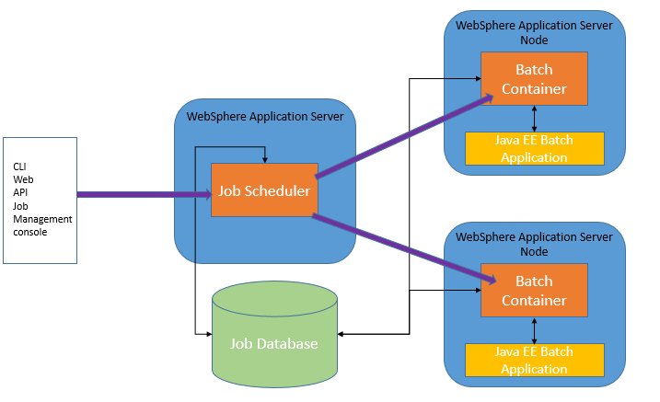

Batch applications are Java EE applications that are designed to run in a non-interactive mode to complete business critical jobs such as report generation, printing documents and etc.

Job scheduler provides all job management functions. Besides basic operations like submitting or restarting a job, they also keep the history of all jobs. In WebSphere Application Server, you can reach the job scheduler in 3 ways:

* Job Management Console, provides a web interface to perform all job management activities.
* Command Line Interface, allows you to submit and control the batch jobs with the help of “lrcmd.(bat|sh)” command.
* APIs, that are available as either web services or EJBs.

Job database contains:

* Scheduler tables store job information in a relational database that is supported by WebSphere Application Server. In a clustered environment, you have to use a network database that is available to all members of the cluster.
* Container tables store check point information of transactional batch applications in a relational database. In a clustered environment, same rules apply to container tables as scheduler tables.

## AIM

# Lab Exercise 13: JOB MANAGEMENT

|  |
| --- |
| Enable Job Sch.  Sample Batch App  Run Batch |

## Enable Job Scheduler

## Install a sample batch application

## Run a batch job

Enable Job Sch.

Sample Batch App

Run Batch



**Task 1: Enable Job Scheduler**

**Step 1:** Navigate to “System administration>Job scheduler”.

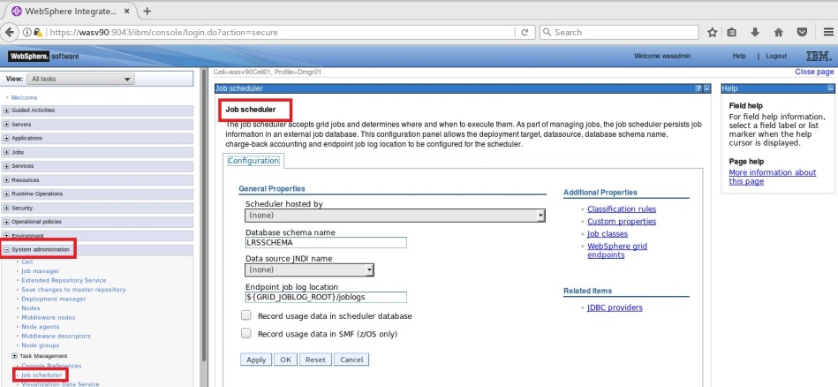

Enable Job Sch.

Sample Batch App

Run Batch



**Step 2:** Select the host to be used as scheduler and use “(none)” as JNDI name and click “OK”.

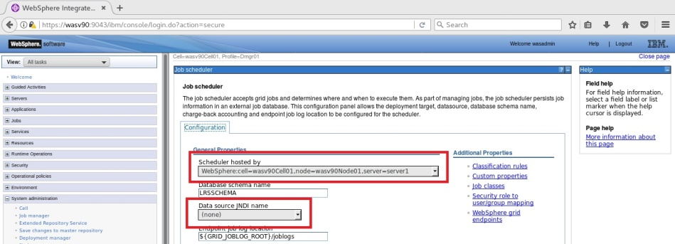

Enable Job Sch.

Sample Batch App

Run Batch



**Step 3:** Click “Save” to write changes. Please pay attention that “jdbc/lnsched” is created and selected automatically.

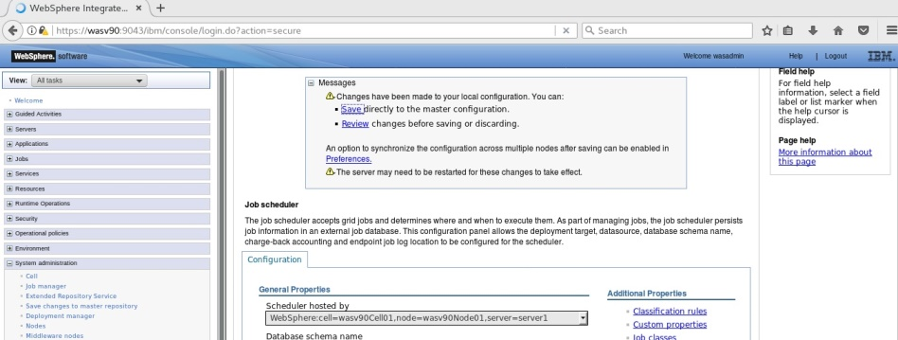

Enable Job Sch.

Sample Batch App

Run Batch



**Step 4:** Click on “Security role to user/group maping”.

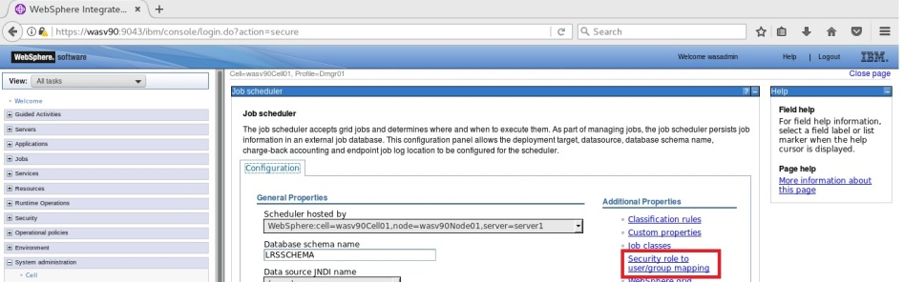

**Step 5:** Select all the roles and click “Map users”.

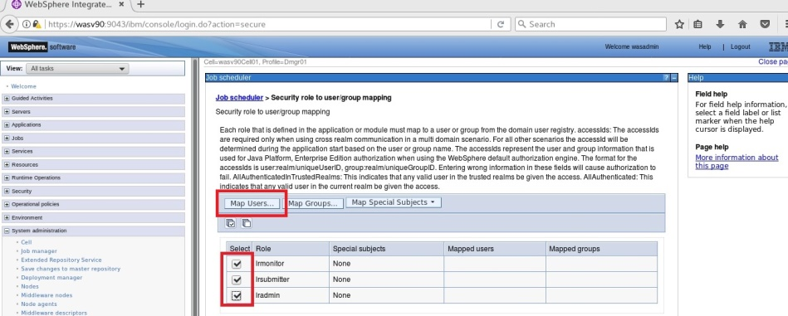

Enable Job Sch.

Sample Batch App

Run Batch



**Step 6:** Search the administrative user and using arrows add to the selected area and click “OK”.

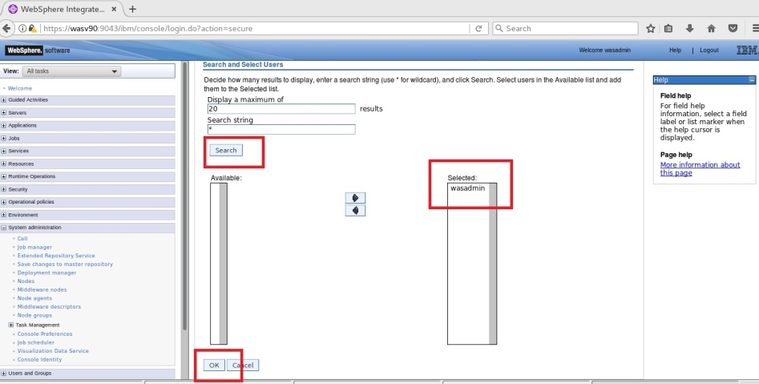

Enable Job Sch.

Sample Batch App

Run Batch



**Step 7:** Click “OK”.

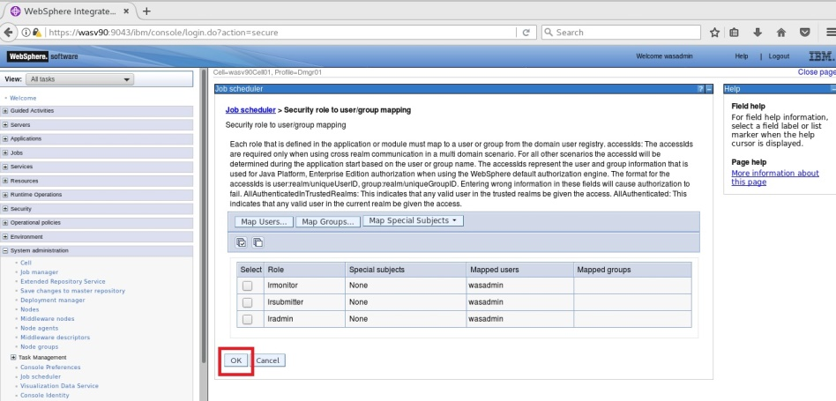

**Step 8:** Click “Save” to write changes.

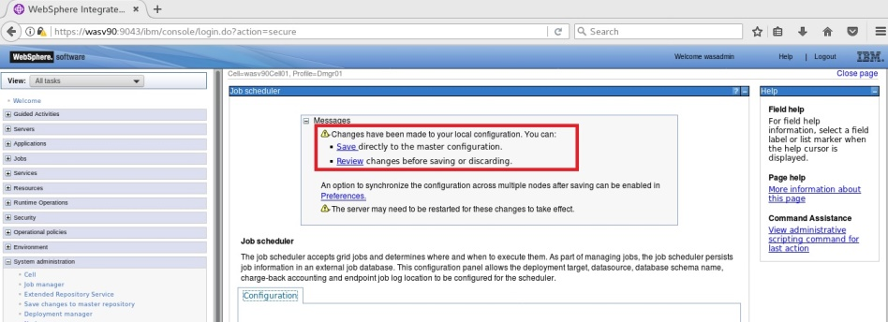

Enable Job Sch.

Sample Batch App

Run Batch



**Step 9:** Navigate to “Servers>Server Types>WebSphere application servers” and select the job scheduler host and click “Restart”.

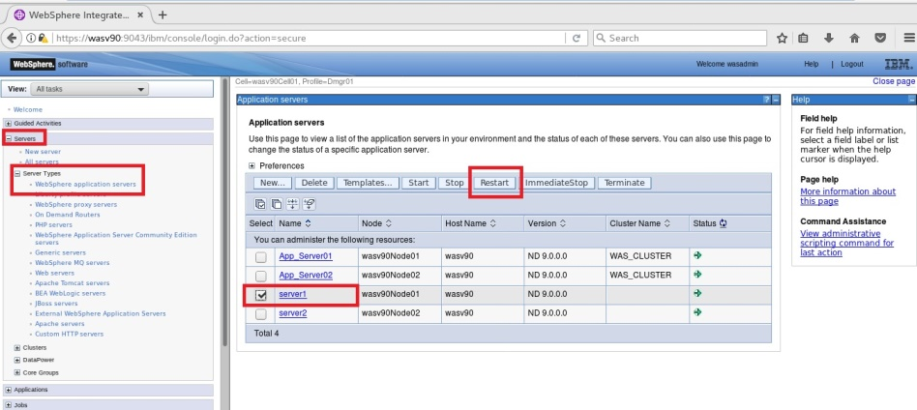

Application server must be restarted successfully.

Enable Job Sch.

Sample Batch App

Run Batch



**Step 10:** Check “WC_defaulthost_secure” port under “Ports” for the job scheduler hosting application server.

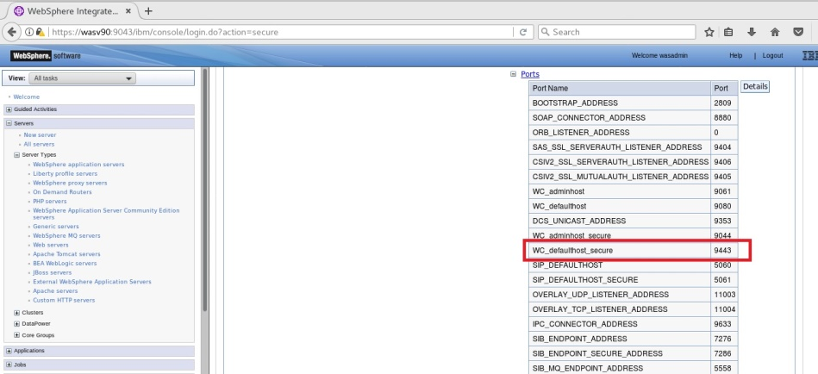

Enable Job Sch.

Sample Batch App

Run Batch



**Step 11:** Navigate to “https://wasv90:9443/jmc”.

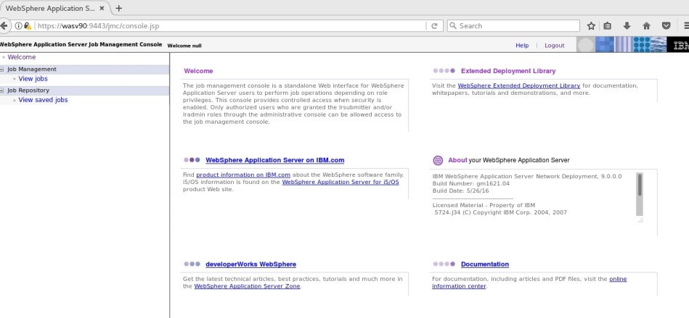

**Task 1 is complete!**

Enable Job Sch.

Sample Batch App

Run Batch



**Task 2: Install a sample batch application**

**Step 1:** Unzip the sample_ivt.zip to “/opt/IBM/”.

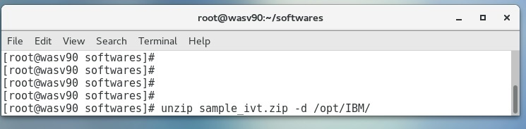

Enable Job Sch.

Sample Batch App

Run Batch



**Step 2:** Change directory to “/opt/IBM/WebSPhere/AppServer/derby/databases” and run “java –Djava.ext.dirs=/opt/IBM/WebSphere/AppServer/derby/lib –Dij.protocol=jdbc:derby: org.apache.derby.tools.ij /opt/IBM/IVT/scripts/CreateIVTTablesDerby.ddl”.

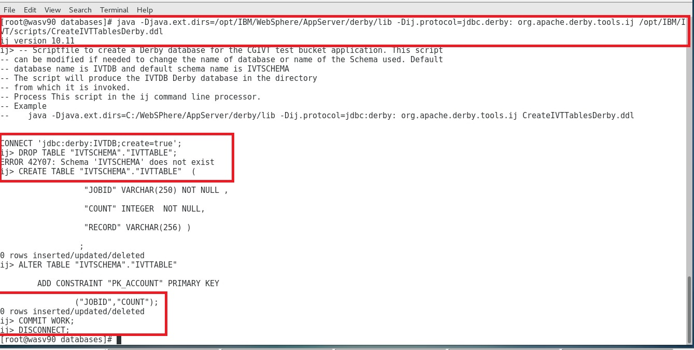

Enable Job Sch.

Sample Batch App

Run Batch



**Step 3:** Navigate to “Resources>JDBC>JDBC providers” and click “New”.

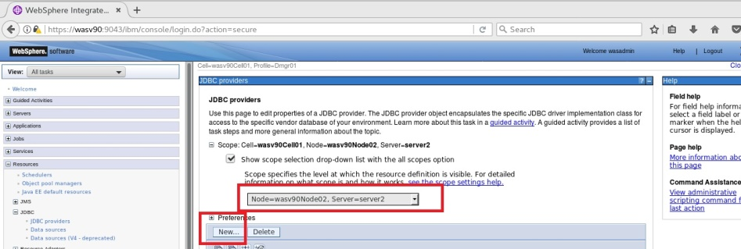

**Step 4:** Add a “Derby” database as follows.

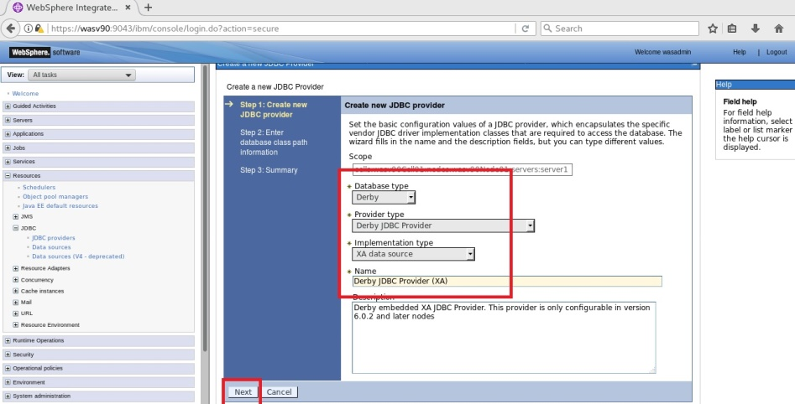

Enable Job Sch.

Sample Batch App

Run Batch



**Step 5:** Click “Finish” to complete.

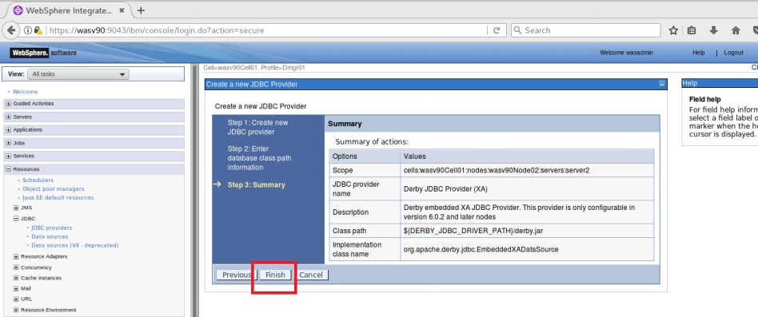

**Step 6:** Click “Save” to write changes.

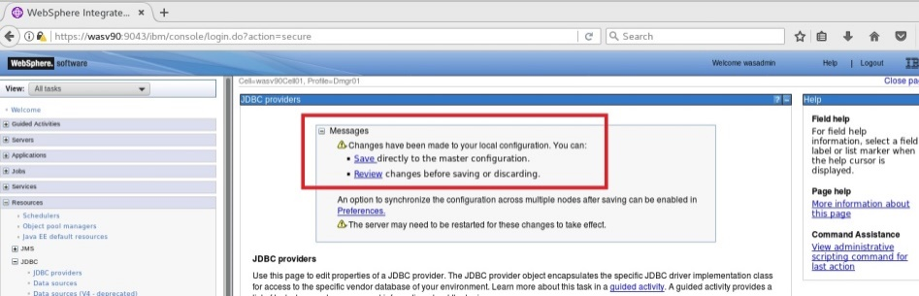

Enable Job Sch.

Sample Batch App

Run Batch



**Step 7:** Navigate to “Resources>JDBC>Data sources” and click “New”.

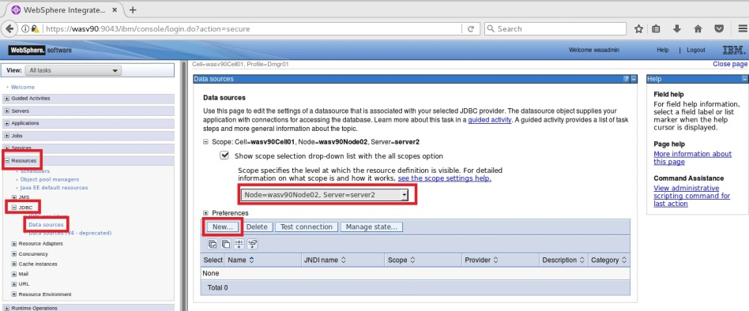

**Step 8:** Use “jdbc/IVTdbxa” as JDNI name and click “Next”.

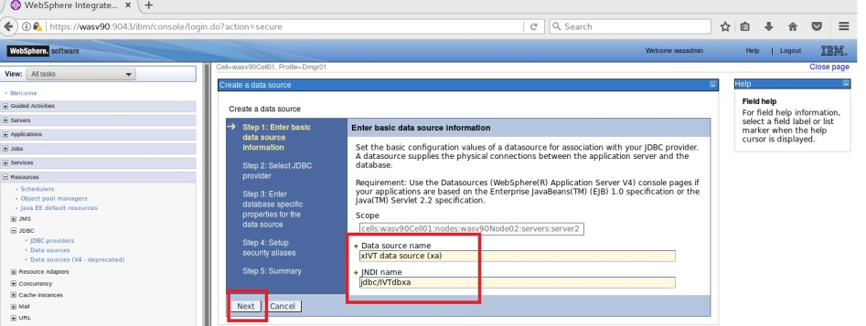

Enable Job Sch.

Sample Batch App

Run Batch



**Step 9:** Select “Derby JDBC Provider (XA)” and click “Next”.

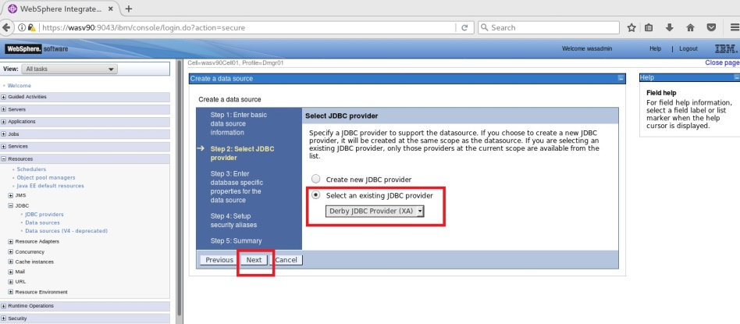

**Step 10:** Eneter “/opt/IBM/WebSPhere/AppServer/derby/databases/IVTDB” and click “Next”.

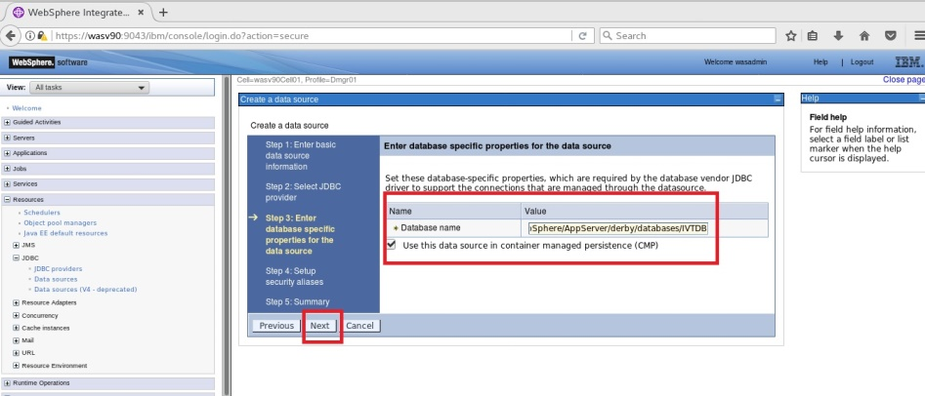

Enable Job Sch.

Sample Batch App

Run Batch



**Step 11:** Click “Next” to continue.

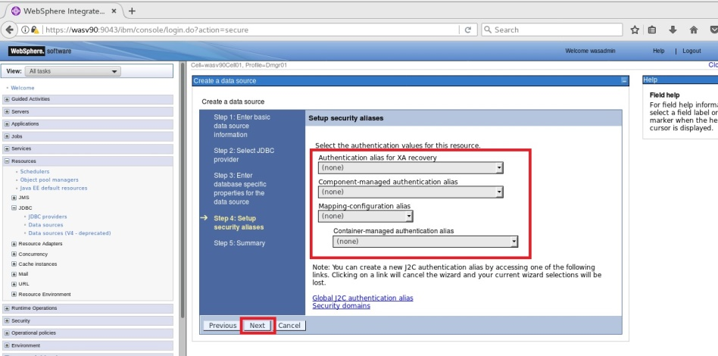

Enable Job Sch.

Sample Batch App

Run Batch



**Step 12:** Click “Finish” to complete.

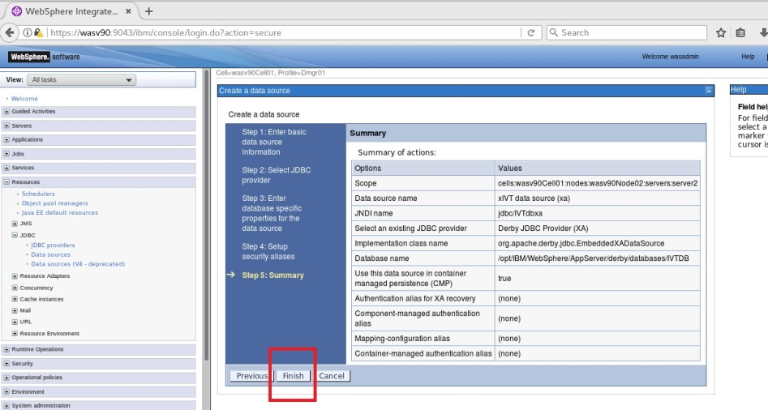

Enable Job Sch.

Sample Batch App

Run Batch



**Step 13:** Select the new data source and click “Test connection” to verify the database conencitvity.

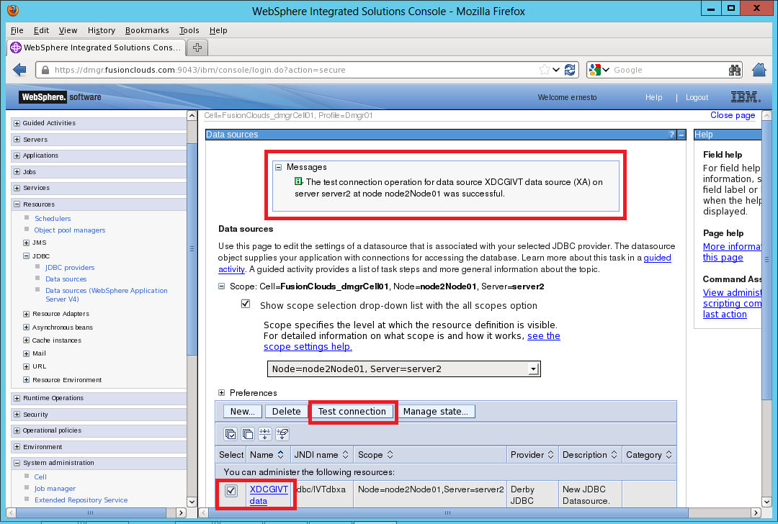

Enable Job Sch.

Sample Batch App

Run Batch



**Step 14:** Navigate to “Applications>New Application” and click “New Enterprise Application”.

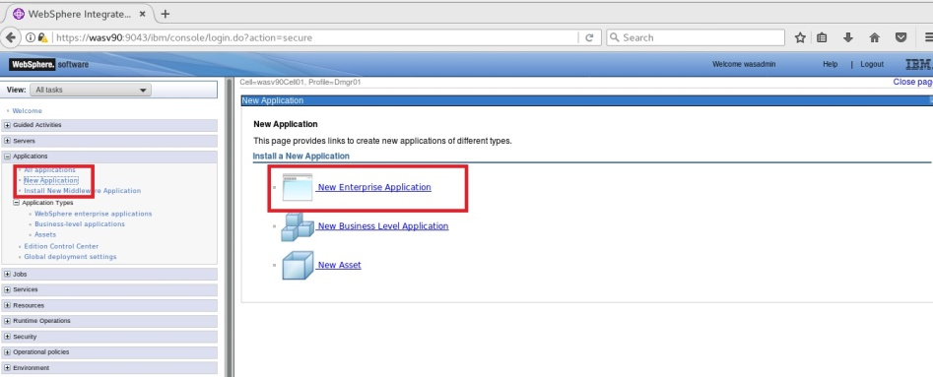

**Step 15:** Browse “/opt/IBM/sample_ivt/sample_ivt/IVT/installableApps/XDCGIVT.ear” and click “Next”.

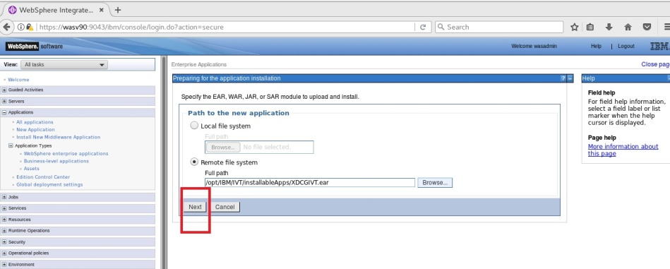

Enable Job Sch.

Sample Batch App

Run Batch



**Step 16:** Select “Fast Path” and click “Next”.

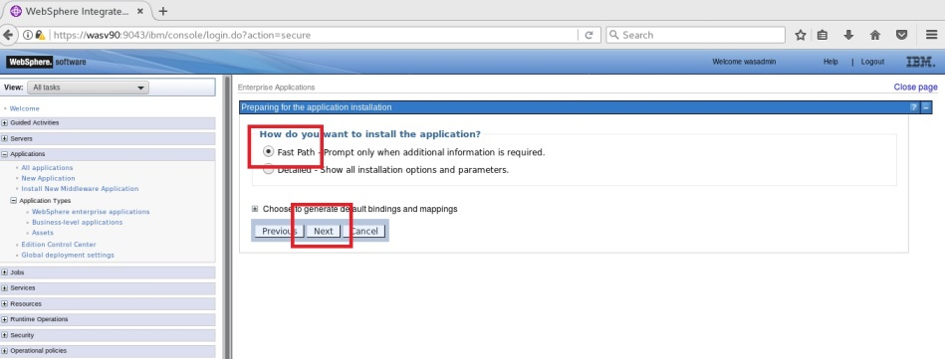

**Step 17:** Accept the default settings and click “Next”.

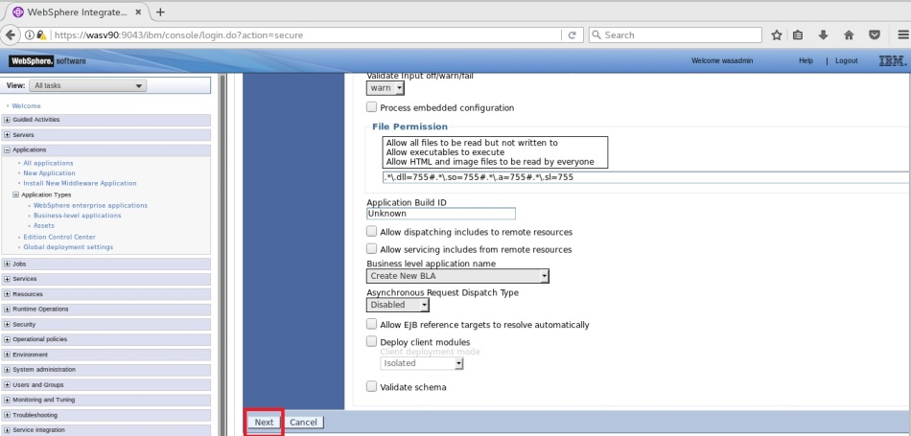

Enable Job Sch.

Sample Batch App

Run Batch



**Step 18:** Map the application to the application server selected as host of the job scheduler and click “Next”.

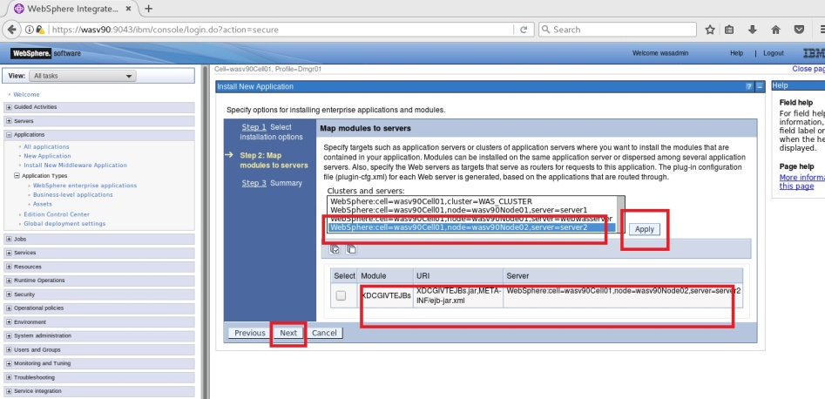

Enable Job Sch.

Sample Batch App

Run Batch



**Step 19:** Click “Finish” and wait for Installation of EAR. You should see the success message then click “Save”.

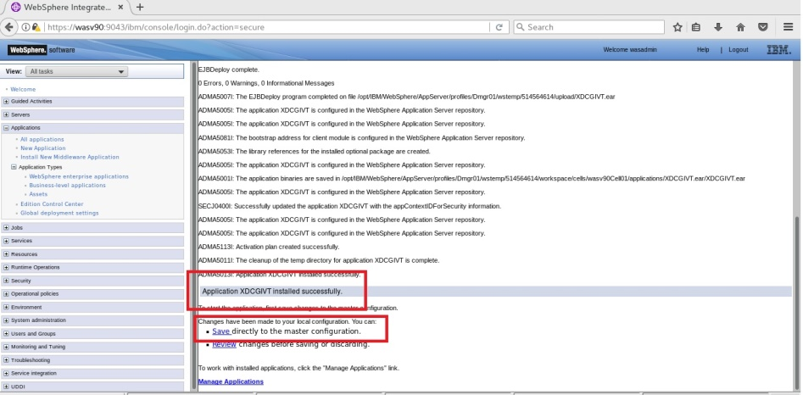

Enable Job Sch.

Sample Batch App

Run Batch



**Step 20:** Restart the application servers.

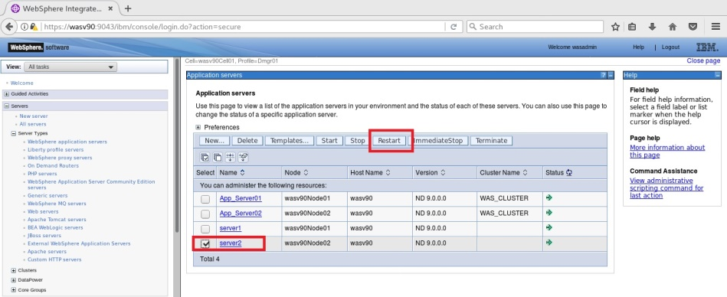

Make sure that restart is successful.

**Task 2 is complete!**

Enable Job Sch.

Sample Batch App

Run Batch



**Task 3: Run a batch job**

**Step 1:** Change "inputDataStream" and “outputDataStream” values according to your environment for the “XDCGIVTtxt2txtxJCL.xml”, “XDCGIVTbyte2bytexJCL.xml” and “XDCGIVTtxt2db2txtxJCL.xml” files under “scripts” folder.

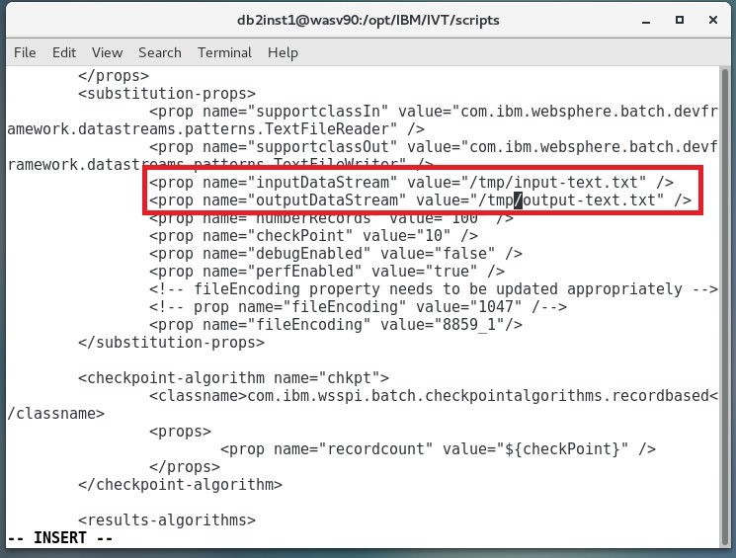

Enable Job Sch.

Sample Batch App

Run Batch



**Step 2:** Login to “Job Management Console” and click on “Submit a job”. Browse “XDCGIVTtxt2txtxJCL.xml” file in “Local file system” and select “Update substitution properties” and click “Submit”.

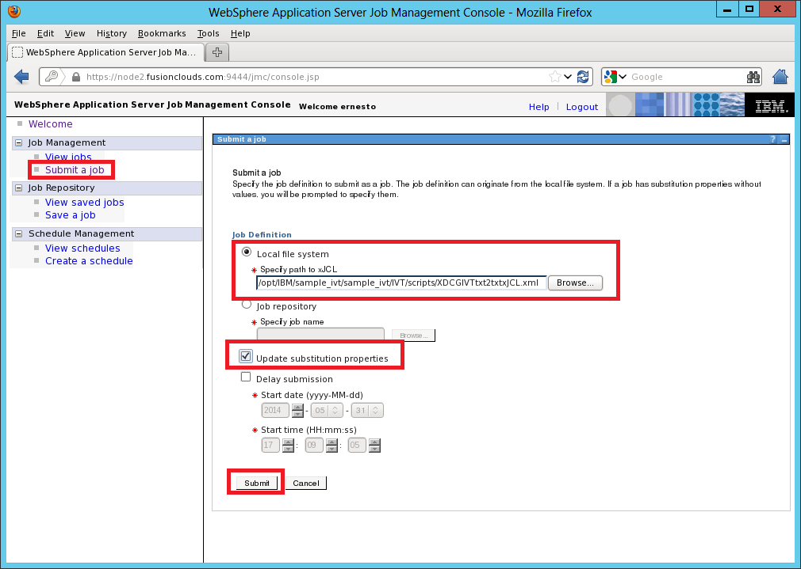

Enable Job Sch.

Sample Batch App

Run Batch



**Step 3:** You can change properties and click “OK”.

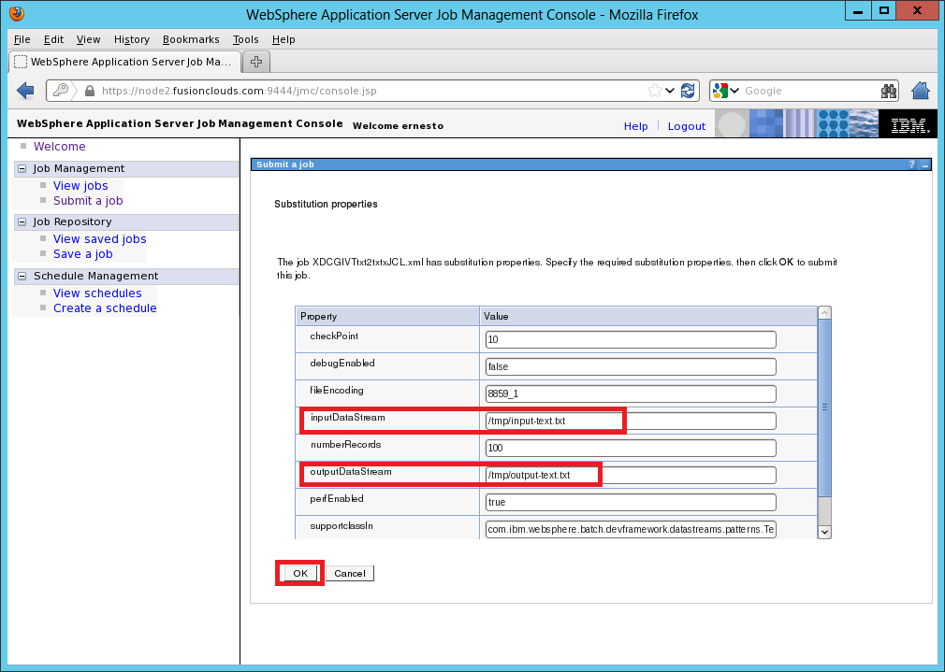

**Step 4:** You should see the job submission success message as follows.

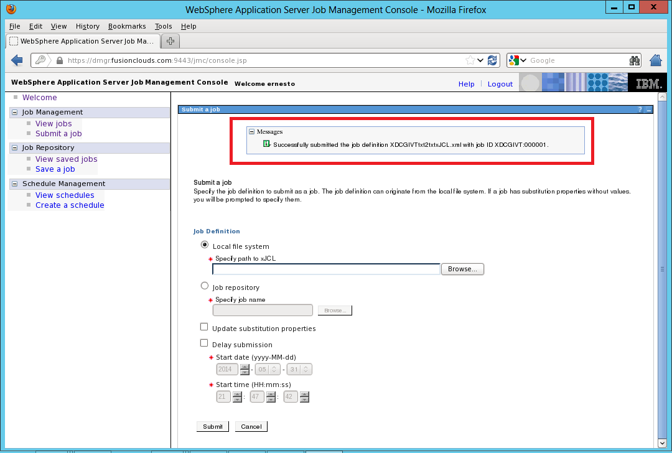

Enable Job Sch.

Sample Batch App

Run Batch



**Step 5:** You can take actions under “Job Management>View jobs” for the specific job.

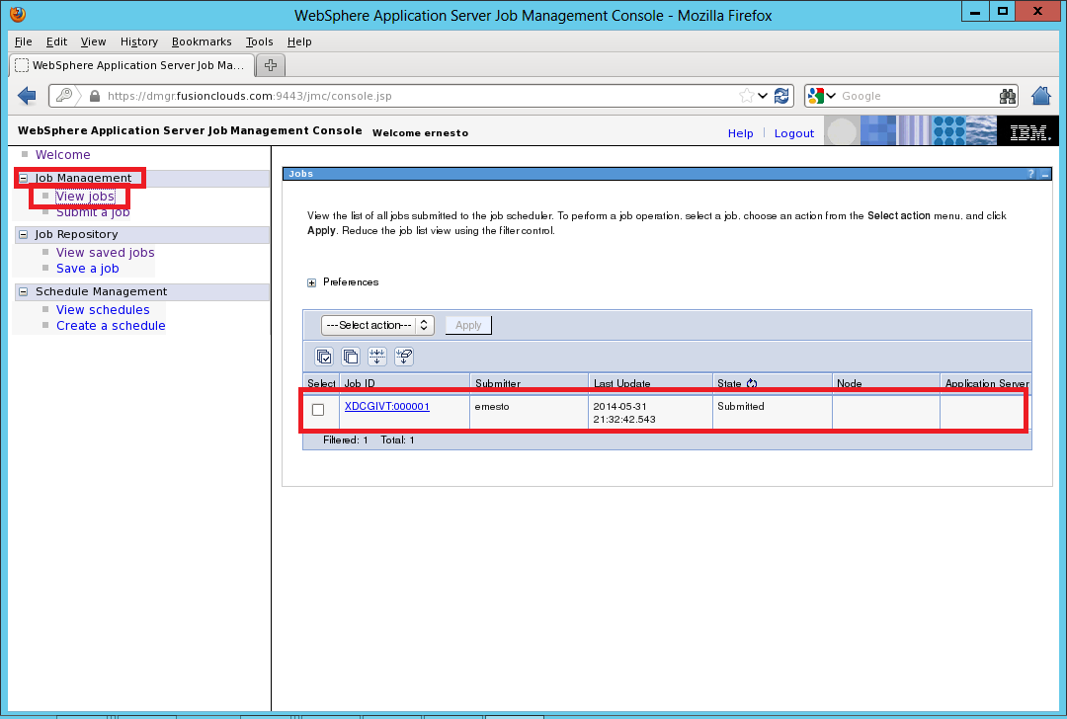

**Task 3 is complete!**

# SUMMARY

Batch applications are used to run complex and long tasks that contain typically transactional and multi-step processes. WebSphere Application Server uses an XML based language, xJCL, to provide consistent architecture that is optimized for Java and long running batch applications. A batch job contains directives to run one or more batch applications. Batch applications are Java EE applications that are designed to run in a non-interactive mode to complete business critical jobs.

# REFERENCES

* http://pic.dhe.ibm.com/infocenter/rsahelp/v8/index.jsp?topic=%2Fcom.ibm.servertools.doc%2Ftopics%2Fbatch%2Fr_profiletemplate_WAS8.html
* http://www.ibm.com/developerworks/websphere/techjournal/1106_alcott/1106_alcott.html

# INDEX

Batch applications 420

batch job 420

Job database 421

Job scheduler 421